Linear Algebraic Implementation of Logic Programming

Hien D. Nguyen^{1,4}
¹ National Institute of Informatics (NII), Japan
²University of Informatics Technology, VNU-HCM, Vietnam

.

Abstract—Logic programming is a logic-based programming paradigm, and provides languages for declarative problem solving and symbolic reasoning. In this paper, we develop new algorithms for computing logic programming semantics in linear algebra. We first introduce an algorithm for computing the least model of a Horn logic program using matrices. Next, we introduce an algorithm for computing minimal models of a disjunctive logic program using third-order tensors. We also develop optimization techniques for speeding-up those algorithms. Finally, the complexity of them is analyzed and tested in practice.
Keywords— logic programming, linear algebra, tensor, Horn programs, disjunctive programs

Introduction
Logic programming is a type of programming paradigm. It provides languages for declarative problem solving and symbolic reasoning. Nowadays linear algebra is the core of many applications of scientific computation. In artificial intelligence, the integration of linear algebraic computation and symbolic computation is one of the challenging topics [1]. There are some studies for realizing logical reasoning using linear algebra.
In [2], the author translated the rules of a Datalog program into a set of matrix equations. Based on this, the least model of this program can be founded by solving the matrix equations. Yang, et al. [3] consider learning representations of entities and relations in knowledge bases using the neural-embedding approach. This method is applied for mining Horn clauses from relational facts represented in a vector space.
Real Logic [6] is a framework where learning from numerical data and logical reasoning are integrated using first order logic syntax. Logic tensor networks (LTN) are one of the modern methods for reasoning and learning from the concrete data as real logic. This method has been applied to semantic image interpretation [7].
Logic programming can be represented based on multilinear algebra. In [4, 5], the authors used multilinear maps and tensors to represent predicates, relations, and logical atoms of a predicate calculus. Lin [12] introduces linear algebraic computation of SAT for clausal theories. Bell, et al. [11] compute minimal models and stable models of normal logic program by mixed integer programming. Besides that, Horn, disjunctive and normal logic programs are also represented by algebraic manipulation of tensors in [8].
In this paper, based on the linear algebraic characterization of logic programs in [8], we present algorithms for finding the least model of a Horn program and minimal models of a disjunctive program. Besides, some improvement methods for speeding-up the working of these algorithms are also studied. These methods are developed based on the structure of tensors which represent logic programs. The complexity of them is evaluated and tested in practice.
The next section reviews some notions in multilnear algebra and foundation of logic programs. Section 3 presents an algorithm for finding the least model of a Horn program based on matrix representation and an optimization technique for speeding-up this algorithm. Section 4 presents an algorithm for finding the minimal models of a disjunctive program based on tensor representation and an improvement method for this algorithm. Section 5 shows experimental results of the above methods by testing in practice. The last section concludes the paper.

Preliminaries
The definitions in this section are from [8, 10]. A k-th order tensor is an element of the tensor product of k vector spaces. A first-order tensor is a vector v ∈ ^{n}, a second-order tensor is a matrix M ∈ ^{m×n}, and a third-order tensor (m, n, p ≥ 1) is a three-way array T ∈ ^{m×n×p}. Slices are two-dimensional sections of a tensor, defined by fixing all but two indices. A third-order tensor T ∈ ^{m×n×p} is decomposed into slices by fixing an index j (1≤ j ≤ p). The j-th slice of a third-order tensor T is a matrix and is written as T_{::j}.
The (2-mode) product of a tensor T ∈ ^{m×n×p} and vector v ∈ ^{n} is denoted by T•v. The result is the m × p matrix that has element 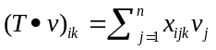.
When M ∈ ^{m×n} is a matrix and v ∈ ^{n}, the product M • v is the standard matrix multiplication that becomes a vector in ^{m}.

Horn program
We consider a language L that contains a finite set of propositional variables and the logical connectives ¬, ∧, ∨ and ←. L contains ◻ and ⊥ representing true and false, respectively. Given a logic program P, the set of all propositional variables appearing in P is the Herband base of P, denoted B_{P}. We assume {◻, ⊥} ⊂ B_{P}.

Matrix representation of Horn program
A logic program P is a Horn (logic) program iff P is a finite set of rules of the form:
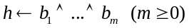          
where h and b_{i} are propositional variables. In particular, the rule (1) is a fact if “h←◻” and (1) is a constraint if “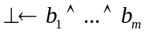”. The fact and the constraint are simply written as “h ←” and “← b₁∧…∧b_{m}”, respectively. A definite program is a Horn program containing no constraint.
Given a rule r as (1) in a Horn program P. Let:
head(r) = h and body(r) = {b₁,…, b_{m}}.
A set {◻} ⊆ I ⊆ B_{P} is an interpretation of P.
An interpretation I is a model of P if {b₁,…, b_{m}}⊆ I implies h ∈ I for every rule (1) in P and ⊥∉ I. A model I is the least model of P if I ⊆ J for any model J of P.
A mapping 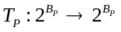is defined as:
.
The powers of T_{P} are defined as:
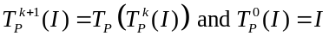 (k ≥ 0).
Given I ⊆ B_{P}, there is a fixpoint 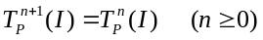.
For a definite program P, the fixpoint 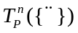coincides with the least model of P.
We semantically identify I = {◻} with I = ∅.
Theorem 3.1 [9]: Let P be a Horn program and a mapping T_{P}.
- Let 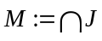, with J is a model of P. Then M is the least model of P.
- M is the least fixpoint of T_{P}, i.e M = .
Definition 3.1: (MD condition for Horn program)
A Horn program P satisfies the MD condition if it satisfies the following condition:
For any two rules r₁ and r₂ in P (r₁ ≠ r₂):
head(r₁) = head(r₂) implies |body(r₁)| ≤ 1 and |body(r₂)| ≤ 1.
(called the multiple definitions (MD) condition).

Lemma 3.1: Let P be a Horn program and M its least model. Then there is a Horn program P’ satisfying the MD condition such that:
P’ has the least model M’ and M’ ∩ B_{P} = M.
Proof. Let S := {r | r ∈ P, |body(r)| > 1}.
P’ = P; B_{P’} = B_{P} ;
With each r = h_{r} ← b_{r1}∧ …∧ b_{rm} ∈ S, generate one new variable c_{r} ∉ B_{P} and two new rules: h_{r} ← c_{r} and c_{r} ← b_{r1}∧ …∧ b_{rm}.
B_{P’} := B_{P} ∪ {c_{r}}.
P’:= P’ \ {r} ∪ {h_{r} ← c_{r} , c_{r} ← b_{r1}∧ …∧ b_{rm}}.
Then P’ satisfies the MD condition and its least model M’ satisfies: M’ ∩ B_{P} = M.

Definition 3.2 [8]: (matrix representation of Horn programs)
Let P be a Horn program satisfying the MD condition and B_{P} = { b₁,…, b_{n}}. Then P is represented by a matrix M_{P} ∈ ^{n×n} such that for each element a_{ij} (1 ≤ i, j ≤ n) in M_{P:}
1. a_{ij} = 1 if b_{i} = ◻ or b_{j} = ⊥.
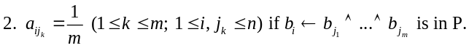 3. Otherwise, a_{ij} = 0.
We write row_{i}(M_{P}) = (a_{i1}, a_{i2}, …, a_{in}) ∈ ^{n} ,
col_{j}(M_{P}) = (a_{1j}, a_{2j}, …, a_{nj})^{T} (1 ≤ i, j ≤ n)
(v^{T} is a transpose of vector v ∈ ^{n}).

Definition 3.3 [8]: (vector representation of interpretations)
Let P be a Horn program and B_{P} = {b₁,…, b_{n}}. Then an interpretation I of P is represented by a vector v = (a₁, . . . , a_{n})^{T} where each element a_{i} represents the truth value of the proposition p_{i} such that a_{i} = 1 if b_{i} ∈ I (1 ≤ i ≤ n); otherwise, a_{i} = 0. The vector representing I = {◻} is written by v_{o}.
Suppose two vectors v = (a₁,…, a_{n})^{T} and w = (b₁,…,b_{n})^{T} representing interpretations I ⊆ B_{P} and J ⊆ B_{P}, respectively.
Then v ≤ w if a_{i} ≤ b_{i} for every 1 ≤ i ≤ n.
Example 3.1:
a) Consider P1 = {p ← q, p ← r, q ← r ∧ s, r ← , ← q} with B_{P1} = {p, q, r, s, ◻, ⊥} then M_{P1} ∈ ^{6×6} is the matrix (right).
The 1st row “011001” represents p ← q, p ← r, p ← ⊥.
The 2nd row “00½ ½01” represents q ← r ∧ s, q ← ⊥.
The 3th row “000011” represents r ←, r ← ⊥.
The 4th row “000001” represents s ← ⊥.
The 5th row “111111” represents ◻ ← p, ◻ ← q, ◻ ← r, ◻ ← s, ◻ ← ◻, ◻ ← ⊥.
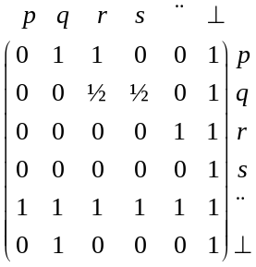 The 6th row “010001” represents ⊥ ← q, ⊥ ← ⊥.
Note that any rule r such that ⊥ ∈ body(r) or head(r) = ◻ is considered as tautology.

b) Consider P2 = {p ← t, t ← q ∧ r, p ← u, u ← s ∧ q, s ← r, r ← q} with B_{P2} = {p, q, r, s, t, u} then M_{P2} ∈ ^{6×6} is the matrix (right).
For simpler representation, we omit ◻ and ⊥ in this example.
The 1st row “000011” represents p ← t, p ← u.
The 3rd row “010000” represents r ← q.
The 4th row “001000” represents s ← r.
The 5th row “0 ½ ½ 000” represents t ← q ∧ r.
The 6th row “0 ½ 0 ½00” represents u ← s ∧ q.
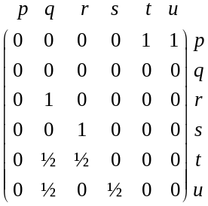

Suppose a matrix M_{P} ∈ ^{n × n} representing a Horn program. Given a vector v ∈ ^{n} representing an interpretation I ⊆ B_{P}, let M_{P} • v = (a₁,…, a_{n})^{T}. We transform M_{P} • v to a vector w = (a₁’,…, a_{n}’ )^{T} where a_{i}’ = 1 (1 ≤ i ≤ n) if a_{i} ≥ 1; otherwise, a_{i}’ = 0. We write w = M_{P} v.
Lemma 3.2 [8]: Let P be a definite program satisfying the MD condition and M_{P} ∈ ^{n×n} its matrix representation. Let v ∈ ^{n} be a vector representing an interpretation I ⊆ B_{P}. Then w ∈ ^{n} is a vector representing J = T_{P}(I) iff w = M_{P}v.
Given a matrix M_{P} ∈ ^{n×n} and a vector v ∈ ^{n}. Define:
M_{P}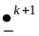v = M_{P}(M_{P}v) and M_{P}v = M_{P}v (k ≥ 1).
When M_{P}v = M_{P}v for some k ≥ 1, we write:
FP(M_{P}v) = M_{P}v.
We have, m ∈ ^{n} is a vector representing the least model of P iff m = FP(M_{P}v_{o}) with v_{o} is a vector representing I = {◻} [8].

Algorithms for finding the least model
Based on theorem 3.2, we have the algorithm for finding the least model of a definite program P that satisfies MD condition:
Input: Let P be a definite program that satisfies the MD condition and F is a set of facts in P.
Output: A vector u representing the least model of P.
Algorithm 3.1:
Step 1: Create the matrix  M_{P} = (a_{ij})_{1≤ i,j ≤ n} representing a Horn program P  for i from 1 to n do  for each rule r in P do  if b_{i} ∈ head(r) then  m := 1/|body(r)|  for j from 1 to n do  if b_{j} ∈ body(r) then  a_{ij} = m  end do; # r in P  end do;  Step 2: Create the vector  v_{o} = (v₁,…v_{n}) representing an interpretation F  for i from 1 to n do  if b_{i} ∈ F then v_{i} = 1  else v_{i} = 0  end do; | Step 3: The least model of P  v:= v_{o}  u:=M_{P} • v  u:= u + v_{o}  for i from 1 to n do  #Transform u = M_{P}v  if u[i] ≥ 1 then u[i] := 1  else u[i]:=0;  end do;  while u ≠ v do  v:= v_{o}  u:=M_{P} • v  u:= u + v_{o}  for i from 1 to n do  #Transform u = M_{P}v  if u[i] ≥ 1 then u[i] := 1  else u[i]:=0;  end do; #while  return u;

Theorem 3.3: Let P be a definite program and mapping T_{P}:
Let 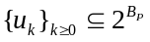 be: 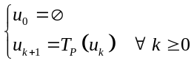
and 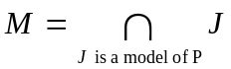.
Then: a) ∀ k ≥ 0, u_{k} ⊆ T_{P}(u_{k}) = u_{k+1} .
b).
c) 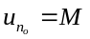.
Proof. a) It can be proved by inductive method.
b) By (a) we have: u_{k} ⊆ T_{P}(u_{k}) = u_{k+1} ∀ k ≥ 0,
and B_{P} has n elements
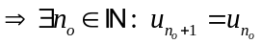 and n_{o} ≤ n.
c) This result proved by Theorem 3.1.
In Algorithm 3.1, the complexity of M_{P}v is O(n²). By the theorem 3.3, the number of times for doing M_{P}v is at most n times. Thus, the complexity of step 3 is O(n³).

Improvement method
To apply Algorithm 3.1, a program P must satisfy the MD condition, so P has to be transformed to P’ satisfying the MD condition by the method in Lemma 3.1.
Given a definite program P, define a set Q_{P} ⊆ P such that:
Q_{P} = {r ∈ P | |body(r)| > 1}.
When Q_{P} ≠ ∅, one new propositional variable and one new rule are introduced to the transformed program P’ for each rule in Q_{P}. In the worst case, when P = Q_{P}, the complexity is estimated as follows:
Let |P| = m and |B_{P}| = n: n’ = |B_{P’}| ≈ n + m
and m’= |P’| ≈ m + m ≈ 2m.
M_{P’} has the size n’× n’ ≈ (n + m) × (n + m).
So the complexity of M_{P’}v is: O(n’²). It is not effective when m >> n.
We introduce a method of decreasing the complexity of the computation u = M_{P’}v:
Let B_{P} = {b₁, b₂,…, b_{n}},
B_{P’} = {b₁, b₂,…, b_{n}, b_{n+1}, b_{n+2},…, b_{n’}},
B_{P’} \ B_{P} = {b_{n+1}, b_{n+2},…, b_{n’}}.
Split a matrix M_{P’} = (a_{ij})_{1≤ i, j ≤ n’} ∈ ^{n’ × n’}, which represents P’, into two matrices:
M¹ = (p_{ij}) has the dimension n × n’ whose rows are all old variables in B_{P} and columns are all variable in B_{P’}: p_{ij} = a_{ij} (1 ≤ i ≤ n, 1 ≤ j ≤ n’)
M² = (q_{ij}) has dimension n × k (k = n’ - n) which rows are all old variables in B_{P} and columns are new variables in B_{P’} \ B_{P}.
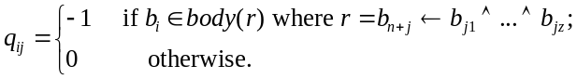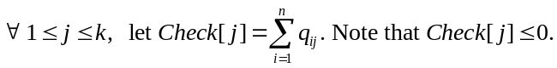
Example 3.2: With a definite program P2 and a matrix M_{P2} in example 3.1b, suppose that {p, q, r, s} is the set of old variables and {t, u} is the set of new variables. Then the matrix M_{P2} is split to M¹ and M² as follows:
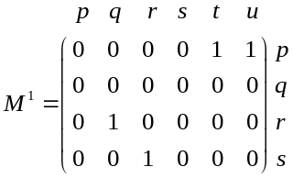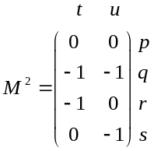

Replace u:= M_{P’}v in step 3 of Algorithm 3.1 by u = M¹v. After that:
- If u[i] = 1 and q_{ij} = -1 then: q_{ij} = 1 (1 ≤ j ≤ n’) ;
- If 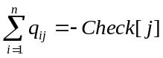 then: u[j] = 1 (1 ≤ j ≤ n’).
Then, the complexity of u = M¹v is O(n×n’), which is much smaller than O(n’²) since n << n’.

Disjunctive logic program

Tensor representation of disjunctive logic program
A logic program P is a disjunctive (logic) program iff P is a finite set of rules of the form:
         
where h_{i} and b_{j} are propositional variables. The rule (2) is called a disjunctive if l > 1. In particular, the rule is fact if the body of (2) is ◻ and it is a constraint if the head of (2) is ⊥. The disjunctive fact is simply written as “h₁∨…∨ h_{l} ← ”.
Given a rule r as (2) in a disjunctive program P. Let:
head(r) = {h₁ , … , h_{l}} and body(r) = {b₁,…, b_{m}}.
A set {◻} ⊆ I ⊆ B_{P} is an interpretation of P.
An interpretation I ⊆ B_{P} is a model of a disjunctive program P if body(r) ⊆ I implies head(r) ∩ I ≠ ∅ for every rule r in P and ⊥ ∉ I.
A model I is a minimal model of P if there is no model J of P such that J ⊂ I.
Definition 4.1: (MD condition for disjunctive program)
A disjunctive program P satisfies the MD condition if it satisfies the following condition:
For any two rules r₁ and r₂ in P (r₁ ≠ r₂):
head(r₁)∩head(r₂) ≠ ∅ implies |body(r₁)|≤1 and |body(r₂)|≤ 1.
(called the multiple definitions (MD) condition).
The notion of the MD condition coincides with the one in Definition 3.1 if P is a Horn program.
Lemma 4.1: Every disjunctive program P can be converted to a disjunctive program P’ satisfying the MD condition such that:
P has a minimal model M iff P’ has a minimal model M’ such that M’ ∩ B_{P} = M.
Proof ¹. Let S := {r | r ∈ P, |body(r)| > 1}.
P’ = P; B_{P’} = B_{P} ;
With each r = h_{r1}∨…∨ h_{rl} ← b_{r1}∧ …∧ b_{rm} ∈ S (l ≥ 1, m > 1), generate one new variable c_{r} ∉ B_{P} and two new rules: h_{r1}∨…∨ h_{rl} ← c_{r} and c_{r} ← b_{r1}∧ …∧ b_{rm}.
B_{P’} := B_{P} ∪ {c_{r}}.
P’:= P’ \ {r} ∪ { h_{r1}∨…∨ h_{rl} ← c_{r} , c_{r} ← b_{r1}∧ …∧ b_{rm}}.
Then P’ satisfies the MD condition such that:
P has a minimal model M iff P’ has a minimal model M’ such that M’ ∩ B_{P} = M.
Given a disjunctive program P, its split program is a Horn program obtained from P by replacing each disjunctive rule of the form (2) in P with a Horn rule:
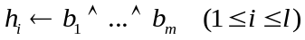
By definition, P has multiple split programs in general. When P has k split programs, it is written as SP₁,…, SP_{k}.
For a set T of interpretations, define the set of minimal elements as:
min(T) = { I | I ∈ T and there is no J ∈ T such that J ⊂ I }.
Proposition 4.1 [8]: Let P be a disjunctive program and SP₁,…, SP_{k} its split programs. Let LM be the set of least models of SP₁,…, SP_{k}. Then min(LM) coincides with the set MM of minimal models of P.
Definition 4.2: (tensor representation of disjunctive programs)
Let P be a disjunctive program satisfying the MD condition. Suppose that P is split into SP₁,…, SP_{k} (k ≥ 1) and B_{P} = {b₁,…, b_{n}}. Then P is represented by a third-order tensor U^{P} ∈ ^{n×n×k} as follows:
1. Each slice U_{::h} (1 ≤ h ≤ k) of U^{P} is a matrix M_{h} ∈ ^{n×n} representing a split program SP_{h}.
2. Each matrix M_{h} ∈ ^{n×n} has an element a_{ij} (1 ≤ i, j ≤ n) such that:
a) a_{ij} = 1 if b_{i} = ◻ or b_{j} = ⊥
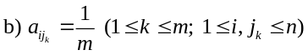
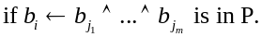
c) Otherwise, a_{ij} = 0.

Example 4.1: Consider the disjunctive program P = {p ∨ r ← s, q ∨ r ←, s ←}, B_{P} = {p, q, r, s, ◻} that has four split programs: SP₁ = {p ← s, q ←, s ←},
SP₂ = {p ← s, r ←, s ←},
SP₃ = {r ← s, q ←, s ←},
SP₄ = {r ← s, r ←, s ←}.
The program P can be represented by the third-order tensor U^{P} ∈ ^{5×5×4} :
¹ The conversion of P in Lemma 4.1 can be made smaller by considering only those rules that do not satisfy the MD condition in S. We here simplify the procedures by omitting those computation steps to collect rules with common atoms in their heads.
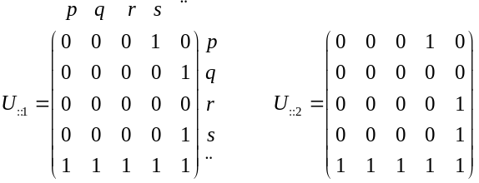
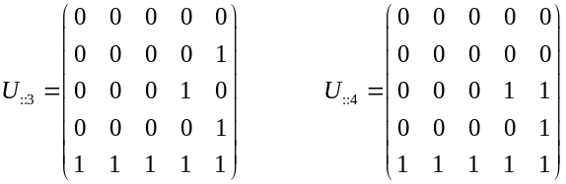
Suppose a third-order tensor U^{P} ∈ ^{n×n×k} . Given a vector v ∈ ^{n} representing an interpretation I ⊆ B_{P}, the (2-mode) product U^{P} • v produces a matrix (a_{ij}) ∈ ^{n×k}. We transform U^{P} • v to a matrix W = (a’_{ij}) ∈ ^{n×k} where a’_{ij} = 1 (1 ≤ i ≤ n, 1 ≤ j ≤ k) if a_{ij} ≥ 1; otherwise, a’_{ij} = 0. We write W = U^{P} v.
Given a tensor U^{P} ∈ ^{n×n×k} and a vector v ∈ ^{n}. Define:
U^{P}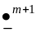v = U^{P}(U^{P}v) and U^{P}v = U^{P}v (m ≥ 1).
When U^{P}v = U^{P}v for some m ≥ 1, we write:
FP(U^{P}v) = U^{P}v.
Theorem 4.1 [8]: Let P be a disjunctive program without constraints that satisfies the MD condition and U^{P} ∈ ^{n×n×k} its tensor representation. Let M_{P} = FP(U^{P} v_{o}) be a matrix where v_{o} represents I = {◻}.
Each column vector m ∈ ^{n} in M_{P} represents a minimal model of P iff m is minimal among all column vectors in M_{P}.

Algorithms for finding the minmal models
Based on theorem 4.1, we have the algorithms for finding the minimal models of a disjunctive program P satisfying the MD condition:
Input: A disjunctive program P satisfying the MD condition and a set F of facts in P. Suppose that P does not contain constraints.
Output: The set MM of minimal models of P.
Algorithm 4.1:
Step 1: Split a disjunctive program P into k Horn programs: SP₁, SP₂,…, SP_{k}  Step 2: Create third-order tensor U^{P} ∈ ^{n ×n ×k} to represent program P  for h from 1 to k do  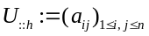  for i from 1 to n do  for each rule r in P do  if b_{i} ∈ head(r) then  m := 1/|body(r)|  for j from 1 to n do  if b_{j} ∈ body(r) then  a_{ij} = m  end if; # b_{i} ∈ head(r)  end do; # r in P  end do;  end do;  Step 3: Find the matrix M ∈ ^{n×k} in which its columns represent the least model of SP_{h} (h =1…k)  3.1 Create the vector v_{F} = (v₁,…v_{n}) representing an interpretation F.  3.2 Create matrix M_{o} ∈ ^{n×k} with col_{i}(M_{o}) =v_{F} (i = 1…k)  3.3 M :=U^{P} • v_{F}  M := M + M_{o}  M’ := M | for i from 1 to n do  # Transform M’ = U^{P} v_{F}  for j from 1 to k do  if M’[i, j] ≥ 1 then  M’[i, j] := 1  else M’[i, j] := 0;  end do;  while M ≠ M’ do  M:= M’  M’ := U^{P} • M  M’ := M + M’  for i from 1 to n do  #Transform M’ = U^{P} M  for j from 1 to k do  if M’[i, j] ≥ 1 then  M’[i, j] := 1  else M’[i, j] := 0;  end do;  end do; #while  Step 4: Find the set MM of vectors which represent minimal models of P  MM := ∅;  for i from 1 to k do  v_{i} := col_{i}(M);  for j from 1 to k do  v_{j} := col_{j}(M);  if (v_{j} ≤ v_{i}) and (v_{j} ≠ v_{i}) then break;  end do;  if j > k then  MM := MM ∪ {v_{i}};  end do;  return MM;

In Algorithm 4.1, the complexity of U^{P}M is O(k²×n²). By the theorem 3.3, the number of times for doing U^{P}M is at most n times. Thus, the complexity of step 3.3 is O(k²×n³).

Improvement method
To apply Algorithm 4.1, a program P must satisfy the MD condition, so P has to be transformed to P’ satisfying the MD condition by the method in Lemma 4.1.
Given a disjunctive program P, define a set Q_{P} ⊆ P such that:
Q_{b} = {r ∈ P | b ∈ head(r) and |body(r)| > 1}.
For any atom b ∈ B_{P}, we have to replace rules satisfying: r ∈ P, b ∈ head(r), |body(r)| > 1 and Q_{b} ≠ ∅. For each rule is replaced, one new propositional variable and one new rule are introduced to the transformed program P’. In the worst case, when P = ∪ Q_{b} (b ∈ B_{P}), the complexity is estimated as follows:
Let |P| = m and |B_{P}| = n: n’ = |B_{P’}| ≈ n + m
and m’= |P’| ≈ m + m ≈ 2m.
U^{P’} has the size n’× n’ × k ≈ (n + m) × (n + m) × k.
M = U^{P’}v_{F} has the size n’ × k.
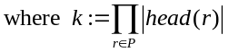.
So the complexity of U^{P’} M is: O(k²×n’²), which is not effective when m >> n.
We introduce a method of decreasing the complexity of the computation U^{P’} M:
Let B_{P} = {b₁, b₂,…, b_{n}},
B_{P’} = {b₁, b₂,…, b_{n}, b_{n+1}, b_{n+2},…, b_{n’}},
B_{P’} \ B_{P} = {b_{n+1}, b_{n+2},…, b_{n’}}.
Split a tensor U^{P’} ∈ ^{n’×n’×k}, which represents P’, into two third-order tensors::
- Define a tensor M¹ ∈ ^{n×n’×k} such that:
.
- Define a tensor M² ∈ ^{n×t×k} (t = n’ - n) such that:
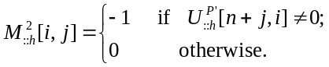
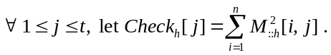
Note that 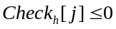
Replace M’ = U^{P’}M in step 3 of Algorithm 4.1 by M’ = M¹M. After this step:
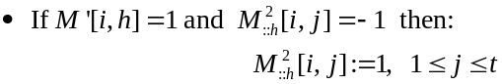
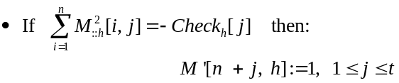
Then, the complexity of M¹M is O(k²×n’×n), which is much smaller than O(k²×n’²) since n << n’.

Experimental results
In this section, we compare runtime for finding the least model of a definite program and the set of the minimal models of a disjunctive program by using the original algorithms and their improved methods.
The testing in this section is run on a system which has configuration as follows:
- Operating system: Window 10, 64-bit.
- CPU: Intel® Core™ i7-4750HQ CPU @ 2.0 GHz, RAM 8.00GB
- Implementation language: Maple 2017, 64 bit [13].

Testing on Horn program
In this testing, a definite program P has been created randomly as follows:
- Given the size n = |B_{P}| of the Herband base B_{P}.
- Given the number m = |P| of rules in P such that:
- Proportion of the rules in P based on number of propositional variables in their bodies
Number of elements in body | 0 | 1 | 2 | 3 | 4 | 5 | 6 | 7 | 8
Number of rules (proportion) | x, where x<n/3 | 4% | 4% | 10% | 40% | 35% | 4% | 2% | The rest
Hence, a program P has more than 95% rules containing more than one propositional variables in their bodies. The size of a program P is N = 9m.
Based on (n, m), generate a definite program P randomly. After that, using Lemma 3.1, we transform P to a program P’ satisfying the MD condition such that:
n’ = the size of Herband base of B_{P’};
m’ = the number of rules in P’.
Table 2 shows the results of testing Algorithm 3.1 on P’ for finding the least model of a program P. There are two important steps in Algorithm 3.1: Step 1 for creating the matrix M_{P’} to represent a definite program P’, and step 3 for finding the fixpoint. There are two methods in step 3:
. Case 1: naive computation M_{P’}v by Algorithm 3.1.
. Case 2: using improvement method as section 3.3.
- Results of testing on definite programs
N | m | Step 3 of Algo. 3.1  (sec.) |  | Proportion faster between case 2 and 1
N | m | Case 1 | Case 2 | Proportion faster between case 2 and 1
20 | 200 | 0.063 | 0.016 | 75%
20 | 400 | 0.25 | 0.016 | 94%
20 | 8,000 | 30.672 | 0.281 | 99%
50 | 1,250 | 1.812 | 0.11 | 94%
50 | 2,500 | 4.906 | 0.188 | 96%
50 | 12,500 | 171.172 | 1.797 | 99%
100 | 5,000 | 24.625 | 1.14 | 95%
100 | 8,000 | 93.63 | 1.859 | 98%
200 | 400 | 0.156 | 0.062 | 60%
200 | 13,300 | 313.578 | 6.703 | 98%
 |  |  | Average | 90.8%
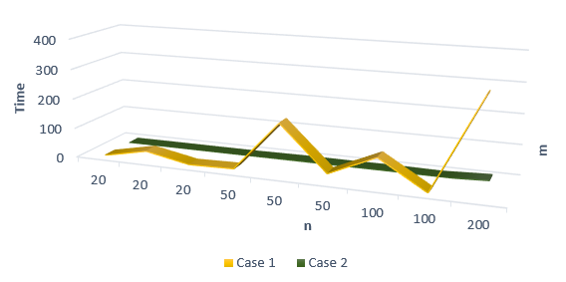
- Result of testing case 1 and case 2 on definite programs
By the table we can observe the following fact: The improved method is more effective than the naïve method, it is 90%+ faster than the former.

Testing on disjunctive programs
In this testing, disjunctive program P has been created randomly as follows:
- Given the size n = |B_{P}| of the Herband base B_{P}.
- Given the number m = |P| of rules in P such that:
About the head of rules:
- Proportion of the rules in P based on number of propositional variables in their bodies
Number of elements in head | 3 | 2 | 1
Number of rules | x  where x ≤ 3 | y  where y ≤ 9 | The rest
Hence the number of definite programs, which are split from P, is 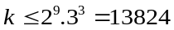.
About the body of rules: The proportions of the number of rules based on number of propositional variables in their bodies are as Table 1.
Hence, program P has more than 95% rules containing more than one propositional variables in their bodies.
Based on (n, m), generate a definite program P randomly. After that, we transform P to a program P’ satisfying the MD condition such that:
n’ = the size of Herband base of B_{P’};
m’ = the number of rules in P’.
k = the number of definite programs SP_{h} that were split from P’.
Table 4 shows the results of testing Algorithm 4.1 on P’ for finding the finding the set of minimal models of a program P. There are three important steps in Algorithm 4.1: Step 2 for creating a tensor U^{P’} representing a disjunctive program P’, step 3.3 for finding the matrix representing least models of definite programs SP_{h}, and step 4 for finding the set of vectors which represent minimal models. There are two methods in step 3.3:
. Case 1: naive computation U^{P’}M by Algorithm 4.1.
. Case 2: using improvement method as section 4.3.
- Results of testing on disjunctive programs
n | m | k | Step 3.3 of Algo. 4.1  (sec.) |  | Proportion faster between case 2 and 1
n | m | k | Case 1 | Case 2 | Proportion faster between case 2 and 1
20 | 40 | 3456 | 5.406 | 7.156 | -32.4% (*)
20 | 100 | 2304 | 48.672 | 22.594 | 53.6%
20 | 300 | 768 | 142.797 | 33.656 | 76.4%
20 | 500 | 576 | 1317.45 | 82.296 | 93.8%
50 | 100 | 1152 | 13.047 | 18.219 | -39.6% (*)
50 | 200 | 768 | 230.484 | 45.094 | 80.4%
50 | 400 | 768 | 1388.922 | 196.844 | 85.8%
50 | 600 | 576 | 3866.531 | 506.875 | 86.9%
100 | 200 | 768 | 35.843 | 90.922 | -153.7% (*)
100 | 400 | 576 | 346.859 | 378.782 | -9.2% (*)
100 | 600 | 512 | 1624.75 | 563.109 | 65.3%
100 | 750 | 288 | 2221.797 | 553 | 75.1%
200 | 400 | 512 | 153.344 | 616.282 | -301.9% (*)
200 | 600 | 256 | 916.422 | 784.969 | 14.3%
200 | 750 | 288 | 2505.438 | 1644.406 | 34.4%
200 | 850 | 256 | 8279.281 | 1898.625 | 77.1%
(*) The negative results mean the slower proportions of case 2 with case 1.

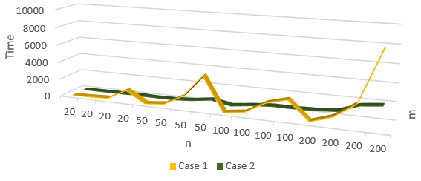
- Result of testing case 1 and case 2 on disjunctive programs
By the table we can observe the following fact:
Comparing the naive method and the improved method: With each n, when m is increased, the effectiveness of the improved method (case 2) is increased too. The improved method is more effective than the naive method (case 1) when m is large, at least m >> 2n. Besides that, the improved method will be valuable when the matrix computation becomes efficient, which can be expected in the near future.

Conclusion
In this paper, we proposed the methods for representing logic programming based on multilinear algebra. We develop new algorithms for computing logic programming semantics in linear algebra and the improvement methods for speeding-up those algorithms.
Firstly, a Horn program is represented by a matrix and an algorithm for finding the least model of it is also designed. This algorithm is improved based on the structure of the matrix which represents a Horn program. The results of the testing show that the improved method is more 90% faster than the naive method in Algorithm 3.1.
Secondly, a disjunctive program is represented by a third-order tensor and an algorithm for computing minimal models of it is also designed. This algorithm is improved based on the structure of the tensor which represents a disjunctive program. The results of the testing show that the improved method is more effective than the naive method in Algorithm 4.1 when m is large, at least m >> 2n.
In future research, we investigate further optimization for computing logic programs in tensors, as well as relaxing the MD condition for representing programs. We also plan to implement an algorithm of computing stable models of normal logic programs based on the method in [8], and to compare it with existing answer set solvers, such as clasp [14] and DLV [15]. Implementing algorithms using parallel computing on GPU is also an promising approach.
The performance of our linear algebraic implementation heavily depends on the manipulation of matrices. We have used Maple for implementation, but our methods can be realized by other computer languages and architectures. It is now expected that more and more powerful platforms are developed for linear algebraic computation in the near future. Our methods would be proved the merits when such advanced technologies become useful. Yet, linear algebraic computation for logic programming has just started, so there will be a lot of rooms for improvement.

References
- V. Saraswat, Reasoning 2.0 or machine learning and logic–the beginnings of a new computer science, Data Science Day, Kista Sweden (2016)
- T. Sato, A linear algebraic approach to Datalog evaluation, Theory and Practice of Logic Programming, Vol. 17, No. 3, pp. 244–265 (2017)
- B. Yang, W. Yih, X. He, J. Gao, L. Deng, “Embedding entities and relations for learning and inference in knowledge bases”, Proceeding of Third International Conference Learning Representations (ICLR 2015), San Diego, USA (2015)
- E. Grefenstette, “Towards a Formal Distributional Semantics: Simulating Logical Calculi with Tensors”, Proceeding of Second Joint Conference on Lexical and Computational Semantics (*SEM), Vol. 1, pp. 1–10, Atlanta, USA (2013).
- B. Coecke, M. Sadrzadeh, S. Clarky, Mathematical Foundations for a Compositional Distributional Model of Meaning, Linguistic Analysis, vol. 36, pp. 345–384 (2011)
- L. Serafini, A. Garcez, “Learning and Reasoning with Logic Tensor Networks”, Proceeding of 15th International Conference of the Italian Association for Artificial Intelligence (AI*IA 2016), LNAI 10037, pp. 334-348, Springer, Genoa, Italy (2016)
- L. Serafini, I. Donadello, A. Garcez, “Learning and Reasoning with Logic Tensor Networks: Theory and application to semantic image interpretation”, Proceeding of 32nd ACM SIGAPP Symposium On Applied Computing (SAC 2017), pp. 125-130, Marrakech, Morocco (2017)
- C. Sakama, K. Inoue, T. Sato, “Linear Algebraic Characterization of Logic Programs”, Proceeding of 10th International conference on Knowledge Science, Engineering and Management (KSEM 2017), LNAI 10412, pp.530-533, Springer, Melbourne, Australia (2017).
- M.H. van Emden, R.A. Kowalski, “The semantics of predicate logic as a programming language”,.Journal of the ACM 23(4), pp. 733–742 (1976).
- T. Kolda, B. Bader, “Tensor Decompositions and Applications”, SIAM Review 51(3), pp. 455-500 (2009)
- C. Bell, A. Nerode, T.Ng. Raymond, V.S. Subrahmanian, “Mixed integer programming methods for computing nonmonotoic deductive database”, Journal of ACM 41(6), pp. 1178-1215 (1994).
- F. Lin, “From satisfiability to linear algebra”, Invited talk, 26th Australian Joint Conference on Artificial Intelligence (2013)
- Maple: https://www.maplesoft.com/support/install/maple2017_install.html
- clasp: https://potassco.org/clasp/
- DLV system: http://www.dlvsystem.com/dlv/

